**Duong Le**

**Professor: Ramakrishna Ayyagari**

**IT360 Software Interprise**

1) Familiarize yourself with the NAV Development Environment

2) Create a Blank Page (with your name) as shown in the videos and provide screenshot

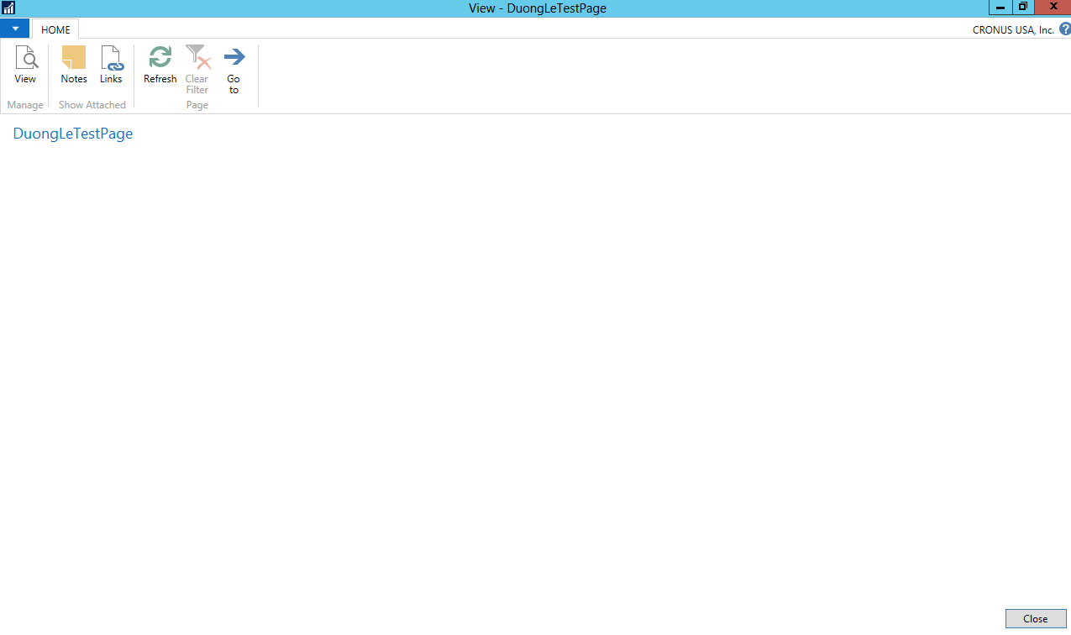

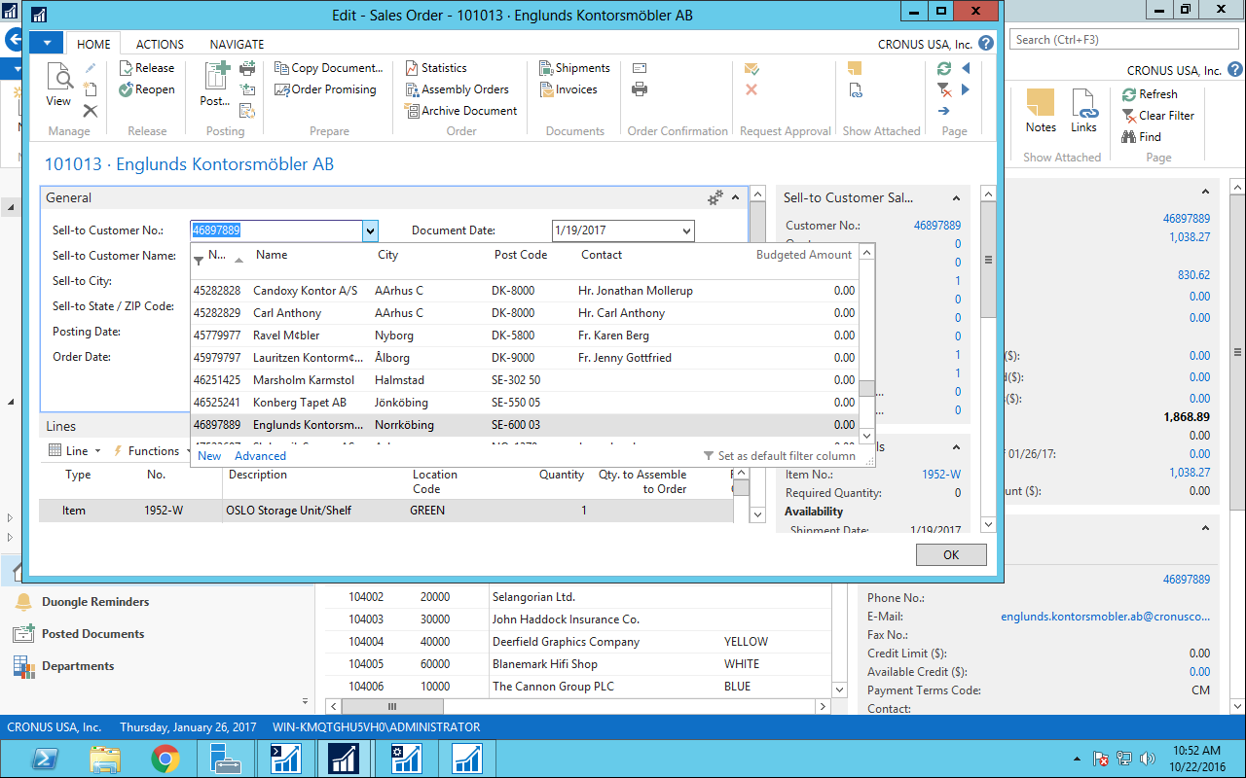3) Update the ‘**Field Groups**’ for Customer so that the ‘DropDown’ for Customer Table in ‘Sales Order’ looks like the following (provide screenshot)